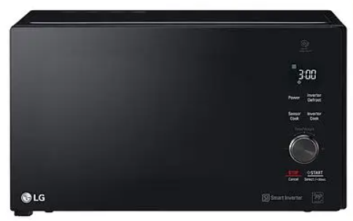
LG Grill Microwave Oven
Rs.36,396
LG Grill Microwave Oven MH8265DIS delivers smart inverter heating, even defrosting, and fast everyday cooking in a spacious 42 litre cavity.

Specifications
- Model: MH8265DIS
- Capacity: 42 Litres
- Technology: Smart Inverter
- Cooking: Grill + Microwave

Key Features
- Even heating
- Even defrosting
- Fast cooking
- Large capacity

